 | 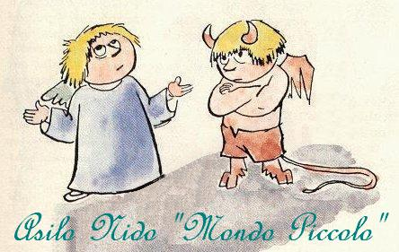  Asilo Nido  “Mondo Piccolo” | ABITUDINI ALIMENTARI E NOTIZIE GENERALI BAMBINI SEMIDIVEZZI E DIVEZZI
DATA DI COMPILAZIONE: ______________
NOME E COGNOME
CLASSE FREQUENTATA: | ETA’ IN MESI:

MANGIO:
- PASTA MICRO (stelline, semini) | - PASTA MEDIA (tubettini, cocciolini)
- PASTA GRANDE (orecchiette, pennette) | - A PEZZI
- CARNE FRESCA | - OMOGENIZZATO
- MISTO (specificare)
____________________________________________________________________________________________________________________________________________________________________________________________________________________________________________________________________________________________________________________________________________________________________________________________________
NON HO INSERITO I SEGUENTI ALIMENTI:
___________________________________________________________________________________________________________________________________________________________________________________________________________________________________________________________________________________________________

SONO ALLERGICO AI SEGUENTI ALIMENTI: SONO A RISCHIO VITA? si no
___________________________________________________________________________________________________________________________________________________________________________________________________________________________________________________________________________________________________

SONO INTOLLERANTE AI SEGUENTI ALIMENTI:
___________________________________________________________________________________________________________________________________________________________________________________________________________________________________________________________________________________________________

NON GRADISCO I SEGUENTI ALIMENTI:
___________________________________________________________________________________________________________________________________________________________________________________________________________________________________________________________________________________________________

ABITUDINI ALIMENTARI DA CORREGGERE:
________________________________________________________________________________________________________________________________________________________________________________________________________________________________________________________________________________________________________________________________________________________________________________________________________________________________________________________________________________________________

INFORMAZIONI UTILI SU ALTRI ASPETTI SANITARI DEL BAMBINO:
__________________________________________________________________________________________________________________________________________________________________________________________________________________________________________________________________________________________________________________________________________________________________________________________________________________________________________________________________________________________________________________________________________________________________________________________________________________________________________________________________________________________________________________________________________________________________________________________________________________________________________________________________________________________________________________________________________________________________________________________________________

Il genitore dichiara di aver preso visione del menù proposto e delle pietanze che verranno somministrate a mensa e chiede di attenersi alle indicazioni contenute in questo modulo, comunicando in seguito eventuali variazioni nelle abitudini alimentari del proprio figlio.
Le allergie, le intolleranze e i problemi sanitari segnalati sono quelli indicati nell’ALLEGATO 1.

FIRMA DEL GENITORE

